

CLOUD COMPUTING LAB
BSE ( V-B )

Submitted By:
Musfira Farooq
Roll No:
2023-BSE-045
Submitted To:
Sir Muhammad Shoaib

LAB 05

Installing, Managing Packages, GUI, and Tools in Ubuntu

Task 1
Java Suggestion Message
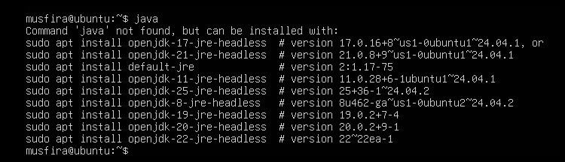
Installing Java using apt
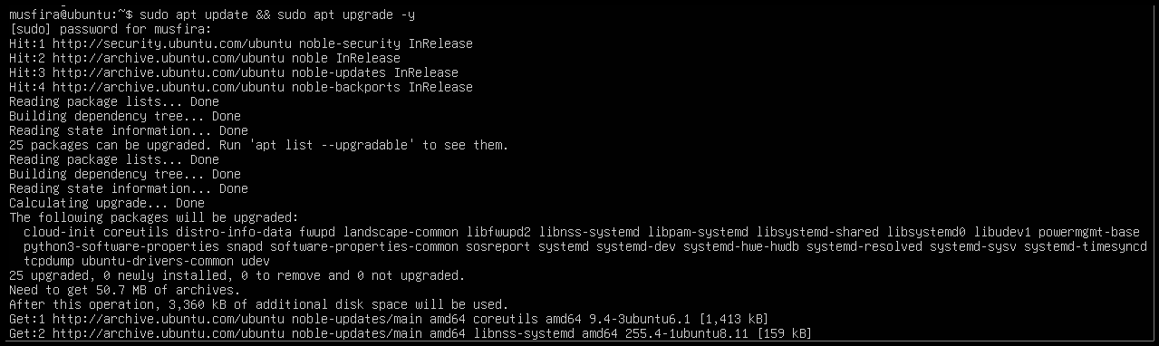
Checking Java Version
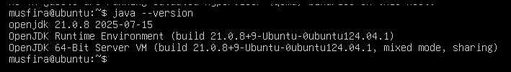
Removing Java Package
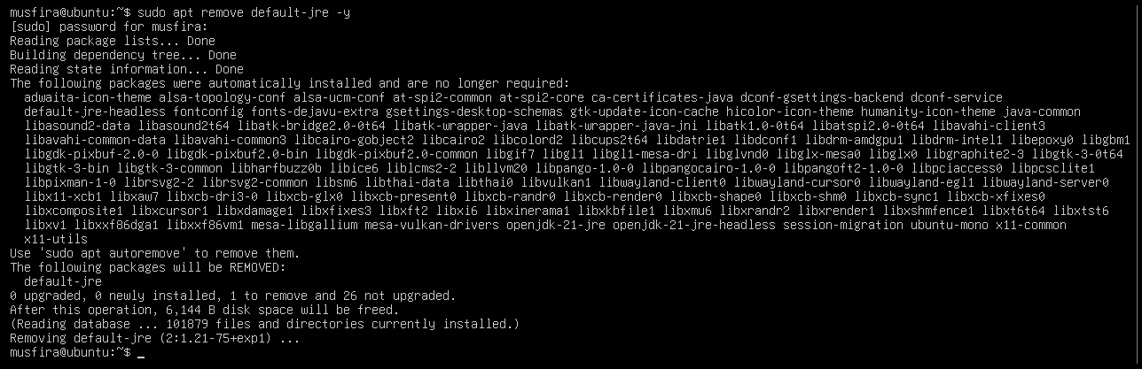
Java Not Found After Removal
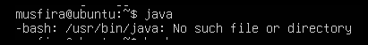
Clearing Shell Cache (hash -r)
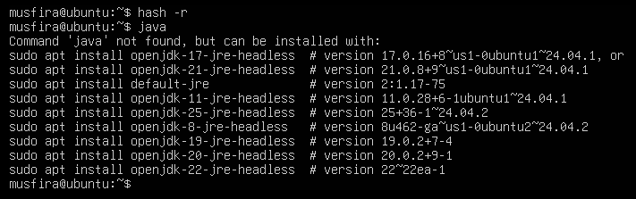

Task 2
Installing Java with apt-get
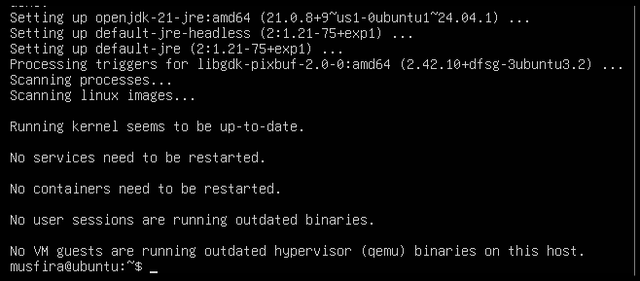
Verifying Java Version
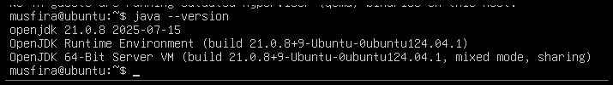
Removing Java using apt-get
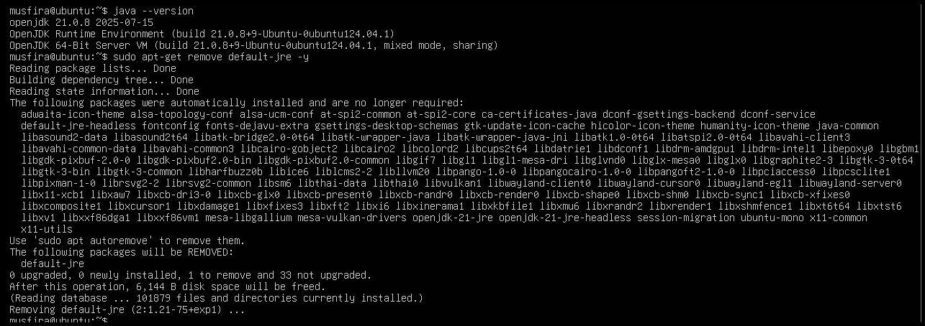
Verifying Java Removed
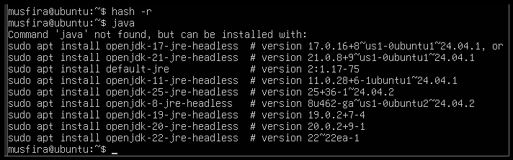

Task 3
Running apt update
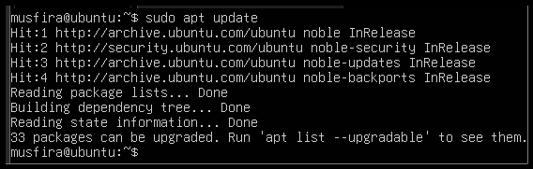
Running apt upgrade
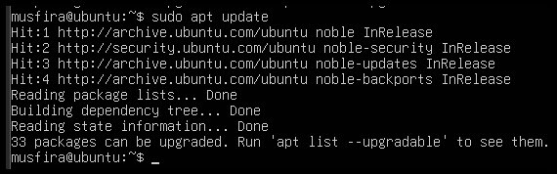
Written Explanation File
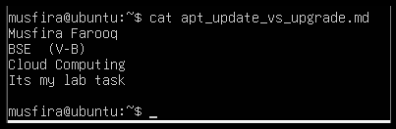

Task 4
Installing VS Code using Snap
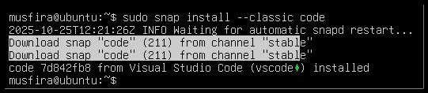
Listing Installed Snap Packages
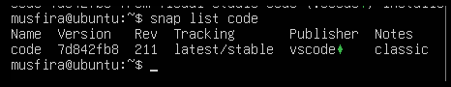
Checking VS Code Version
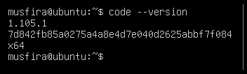
Snap Binary Location for Code
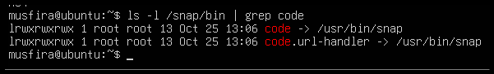

Task 5
Updating Packages

Installing XFCE4 Desktop Environment
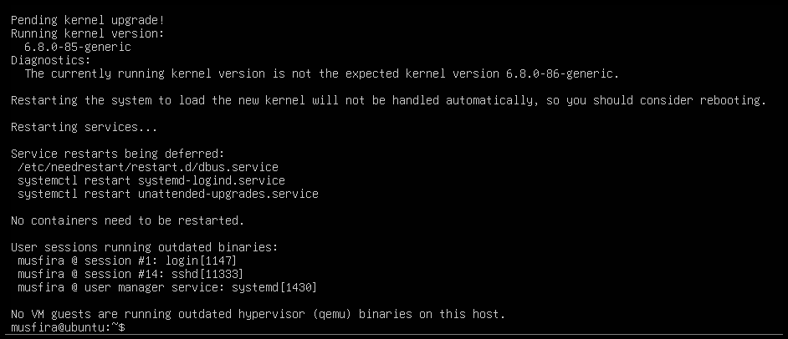
Enabling XRDP Service
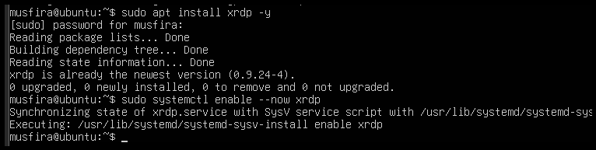
Checking XRDP Status
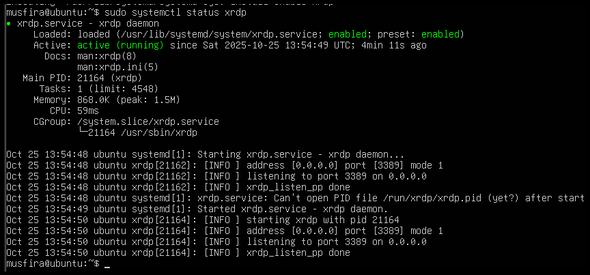
Configuring .xsession for XFCE
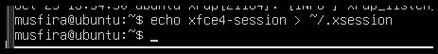
Remote Desktop Connection Established
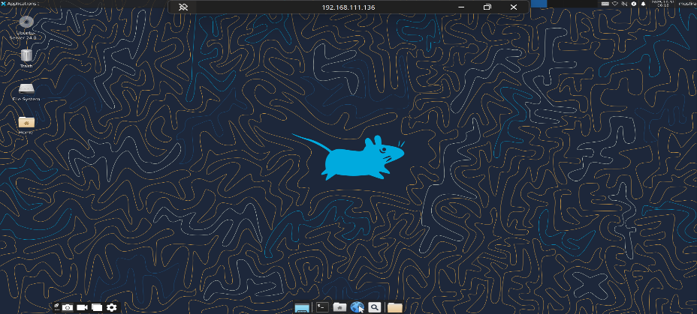
Launching VS Code in GUI
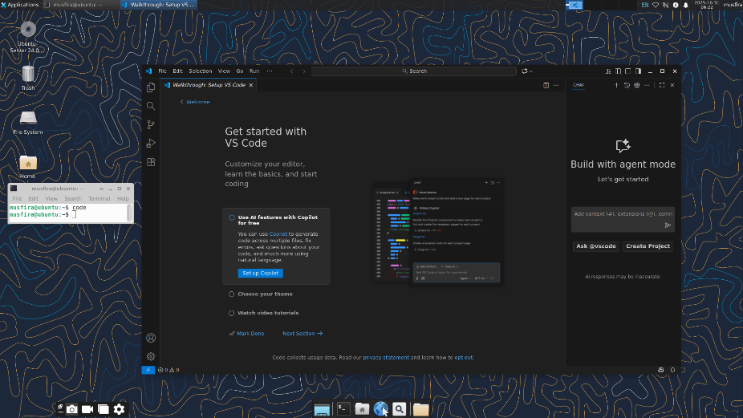
Task 6
Installing LightDM and Greeter
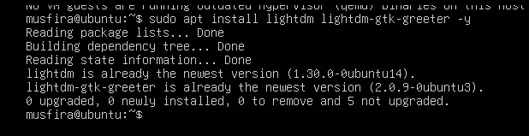
Configuring LightDM for XFCE
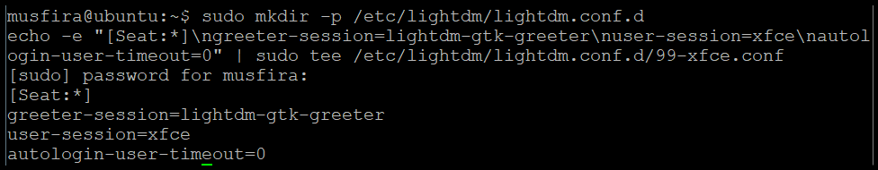
Cleaning Session Files
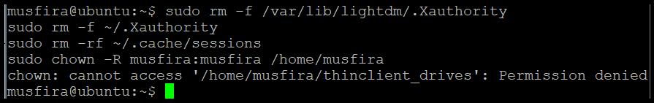
Restarting LightDM Service
Enabling GUI on Boot
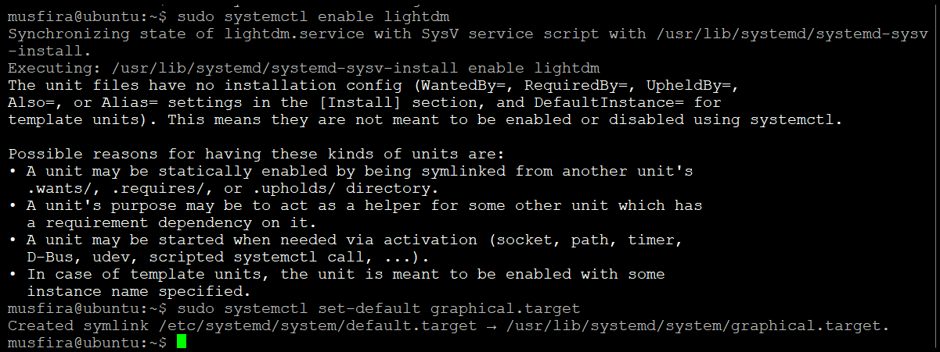
GUI Login After Reboot
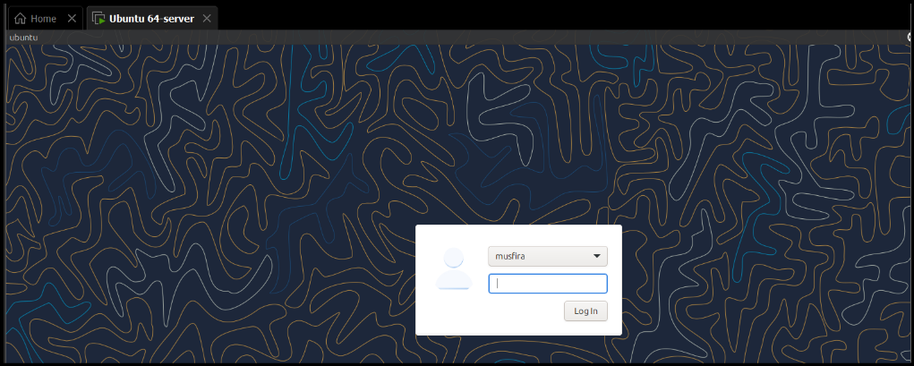
Disabling GUI on Boot
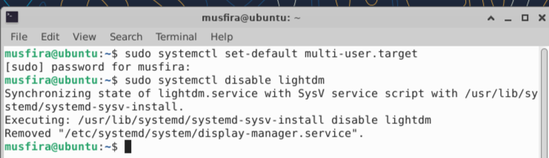
CLI Mode After Reboot
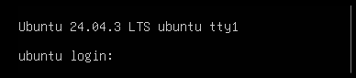
Starting GUI Manually
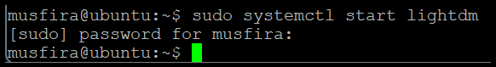
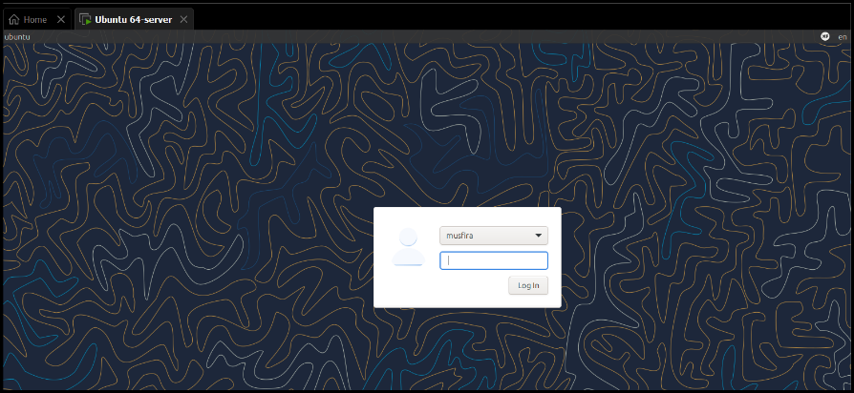
Stopping GUI Manually
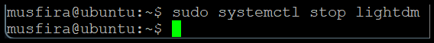
GUI Start Command Displayed
Launching VS Code from GUI
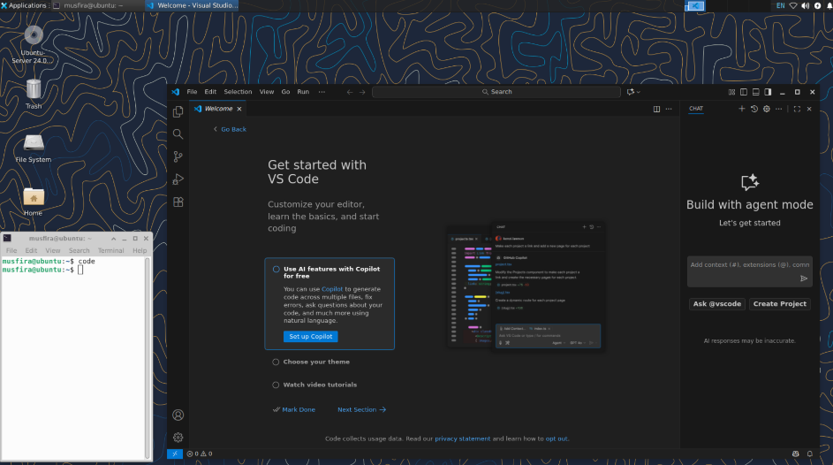
Task 7
Chrome Install Error Message
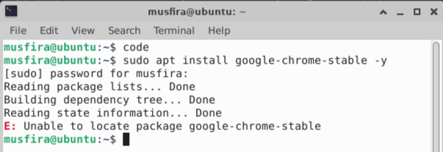
Listing apt Directory Contents
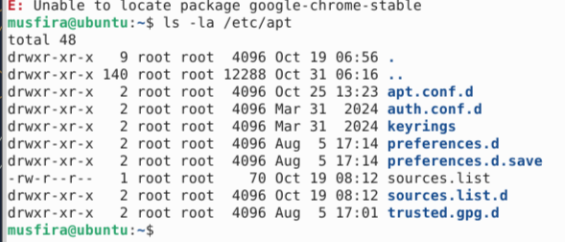
Viewing sources.list File
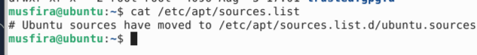
Viewing sources.list.d Directory
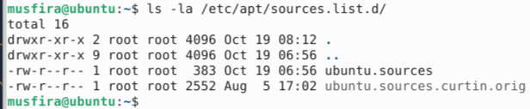
Editing ubuntu.sources to Add Chrome Stanza
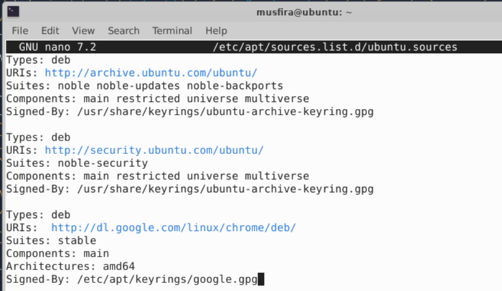
Adding Google Signing Key
Updating Packages
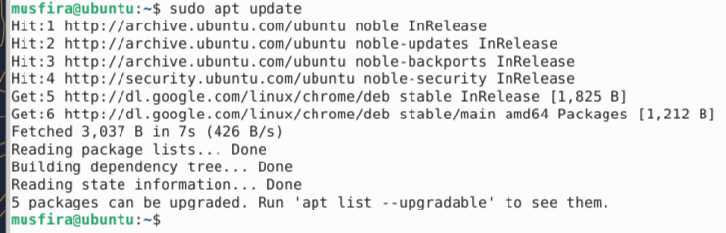
Installing Google Chrome
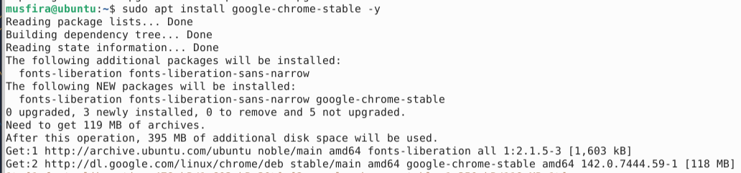
Removing Chrome Package
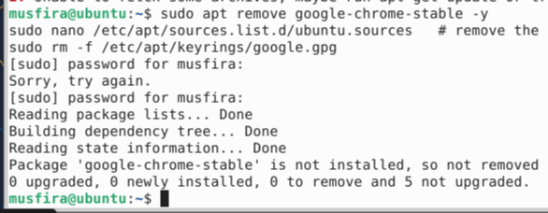
Editing File to Remove Chrome Stanza
Removing Google Key
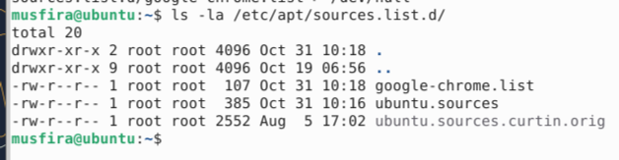
Creating google-chrome.list File
Verifying sources.list.d Directory After Creation
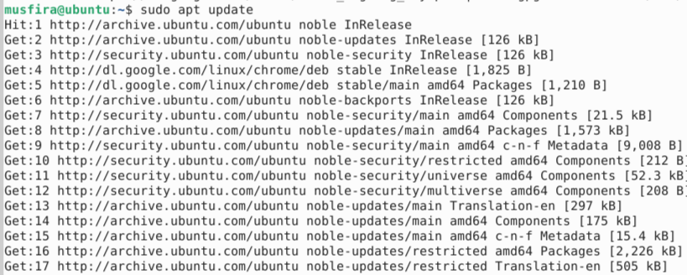
Final Chrome Installation Success
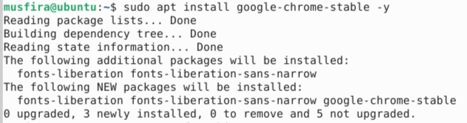

Task 8
Adding Audacity PPA
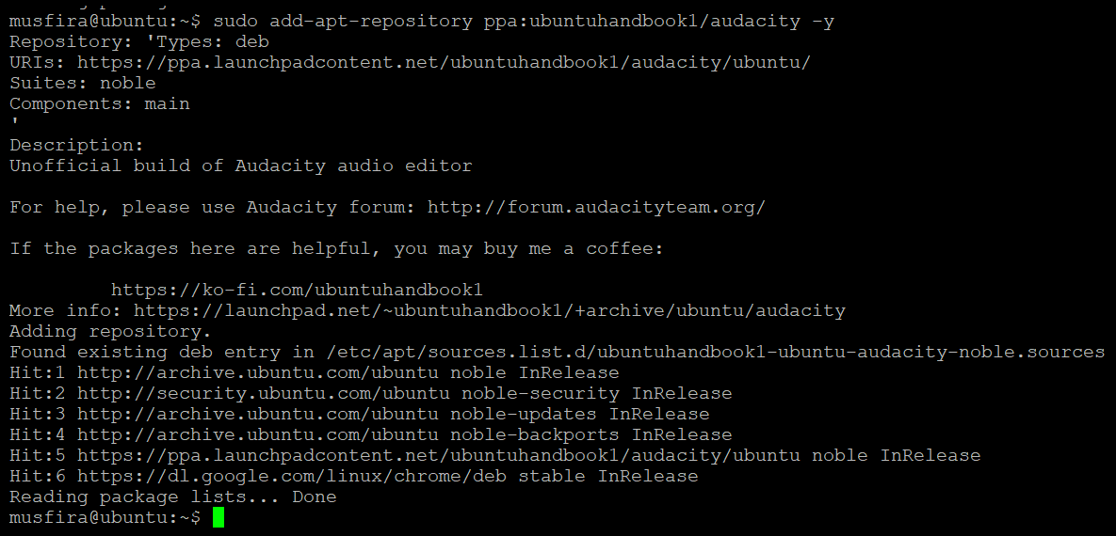
Updating Repositories for Audacity
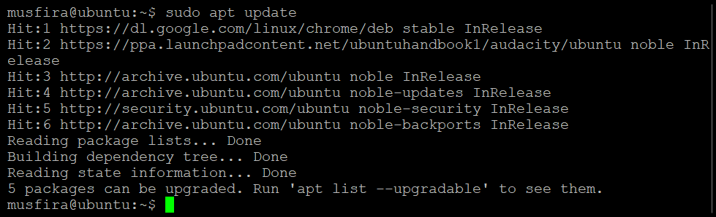
Installing Audacity
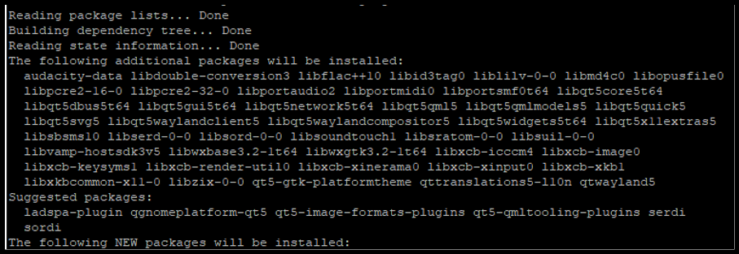
Launching or Verifying Audacity
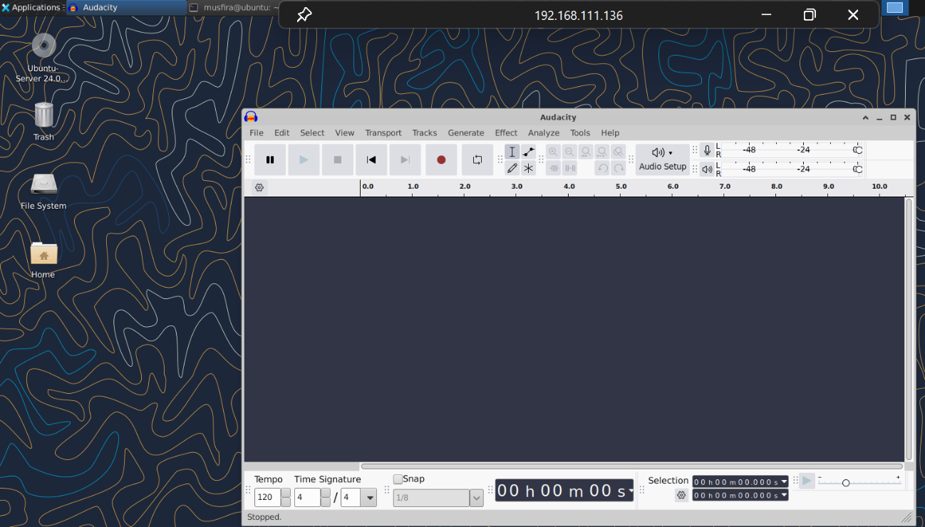
Adding OBS PPA
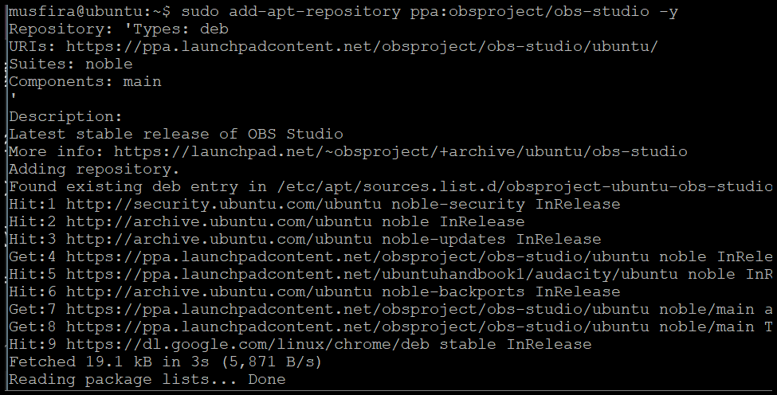
Updating Repositories for OBS
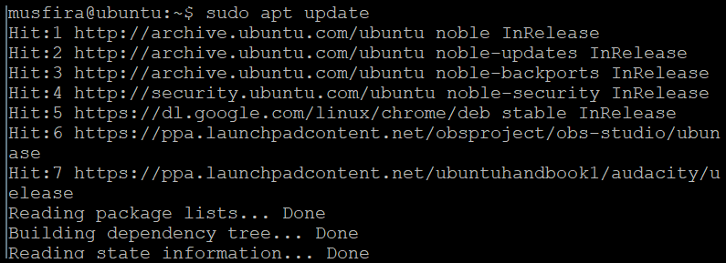
Installing OBS Studio
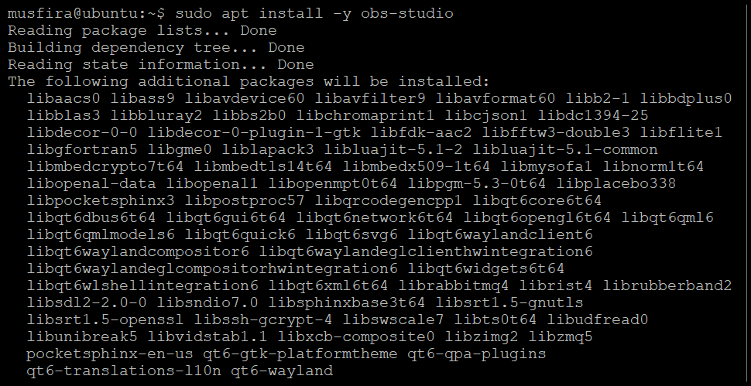
Updating again
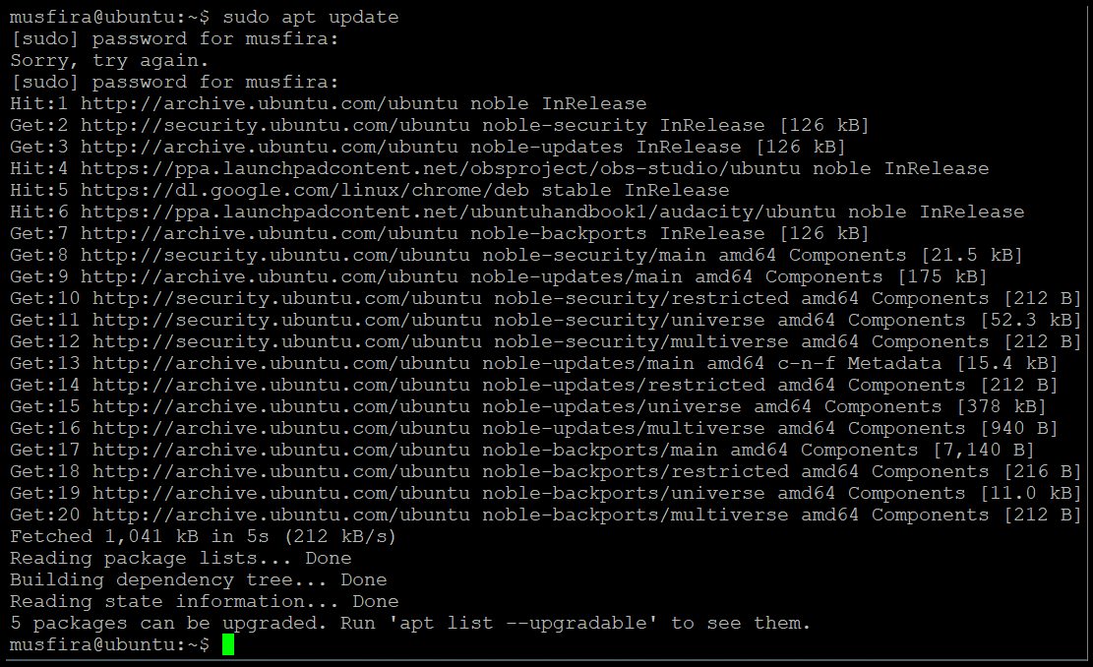
Launching or Verifying OBS Studio
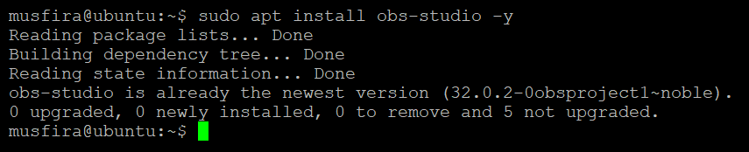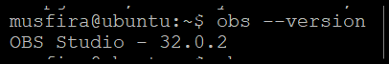
Task 9
Checking Vim Installation
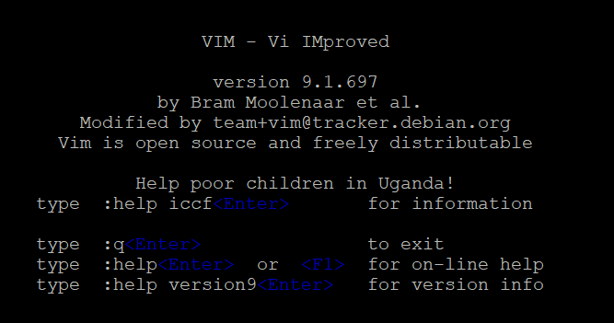
Creating Lab5 Directory and Navigating
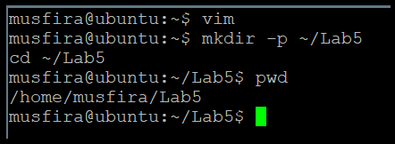
Editing k8s-sample.yaml in Vim
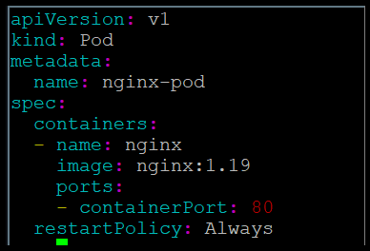
Verifying YAML File Saved
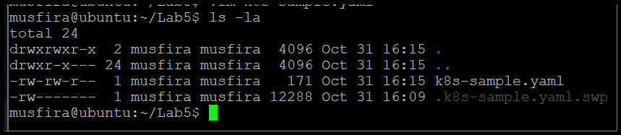
Task 10
YAML File After Adding Annotation
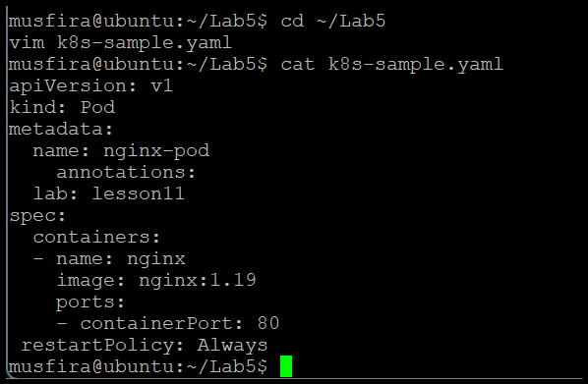
Temporary Edit in Vim (Before Discarding)
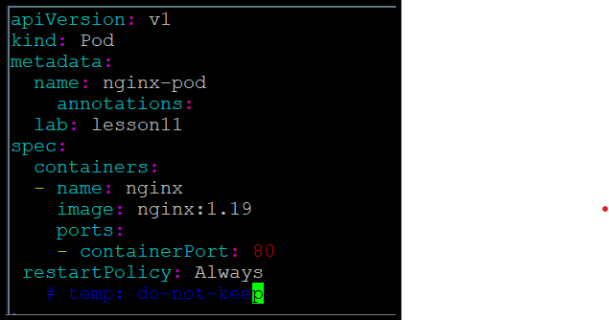
File After Discarding Temporary Changes
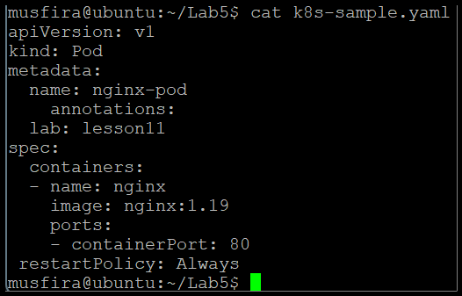

Task 11
Deleting a Line and Undoing
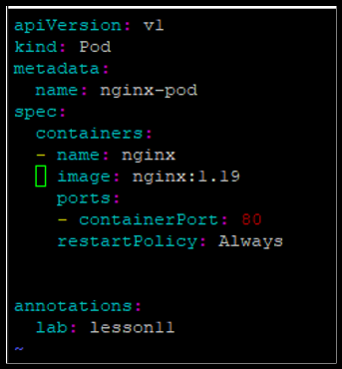
Deleting 3 Lines and Undoing
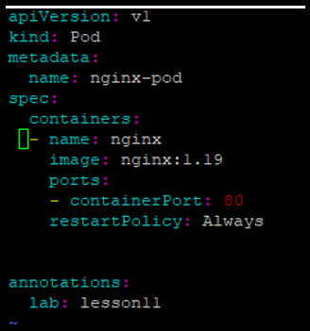
Navigating to Line 1
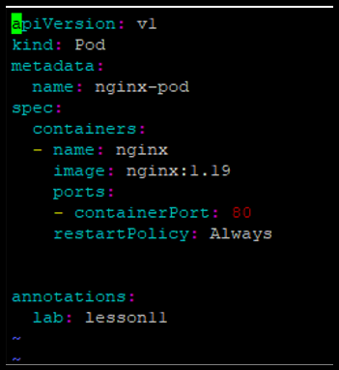
Navigation Between Line Ends
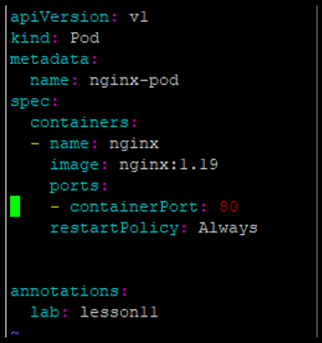
Task 12
Searching for “nginx”
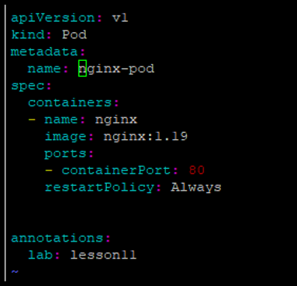
Navigating Matches with n / N
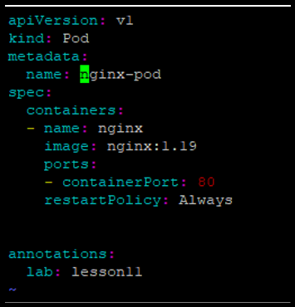
Adding Extra “nginx” Occurrences
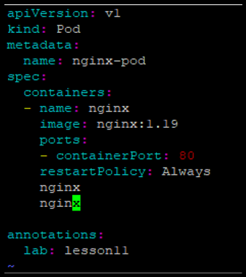
Navigating Between Matches
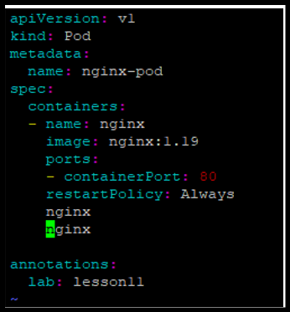
Substituting nginx → webapp
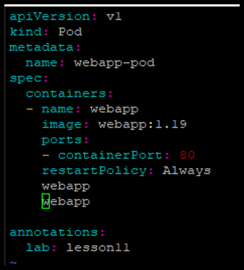
Undoing Substitution
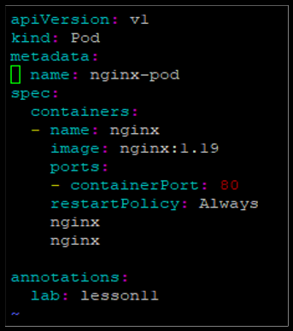

Exam Evaluation
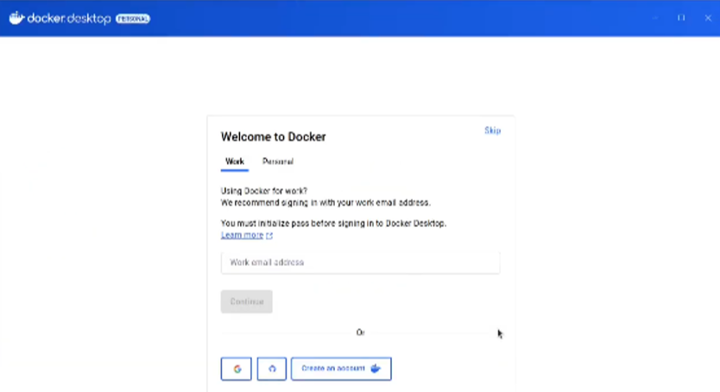
Docker Desktop Successfully Installed
